**Experiment 10**

**Aim/Overview of the practical:**

* Create Windows 2019 server VM on azure portal and access it using your PC?

**Code/Steps for the Practical:**

**Step 1)** Go to Azure portal and login with your credentials.

**Step 2)** Click on **“Create a Resource”** in the top left corner.

**Step 3)** From the list of items select **Windows Server 2019 Datacenter.**

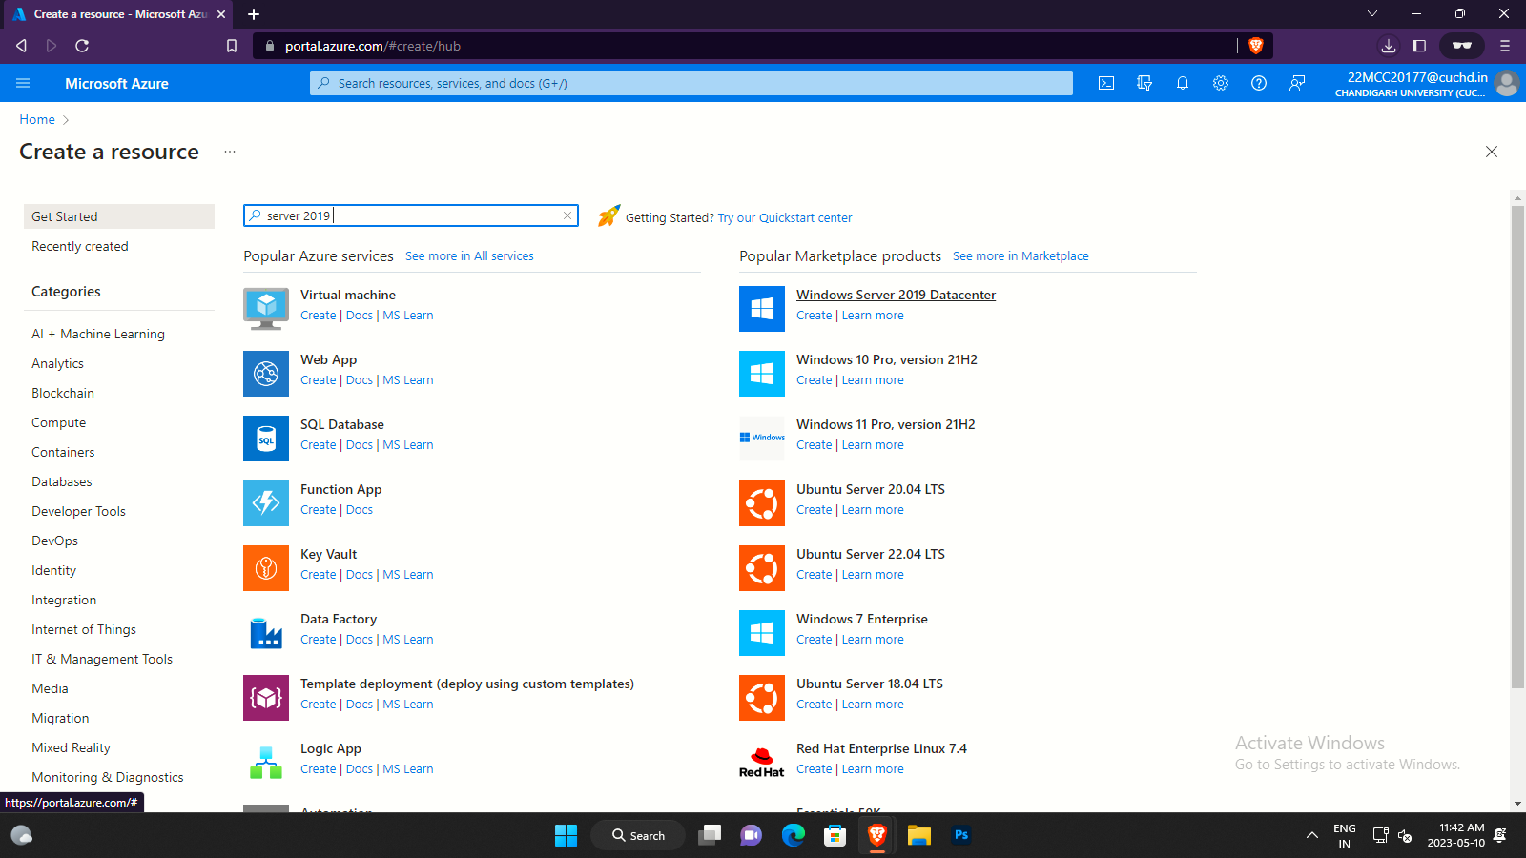

**Step 4)** A newly **Create a virtual machine** window will open. Fill in all the details according to your requirements.

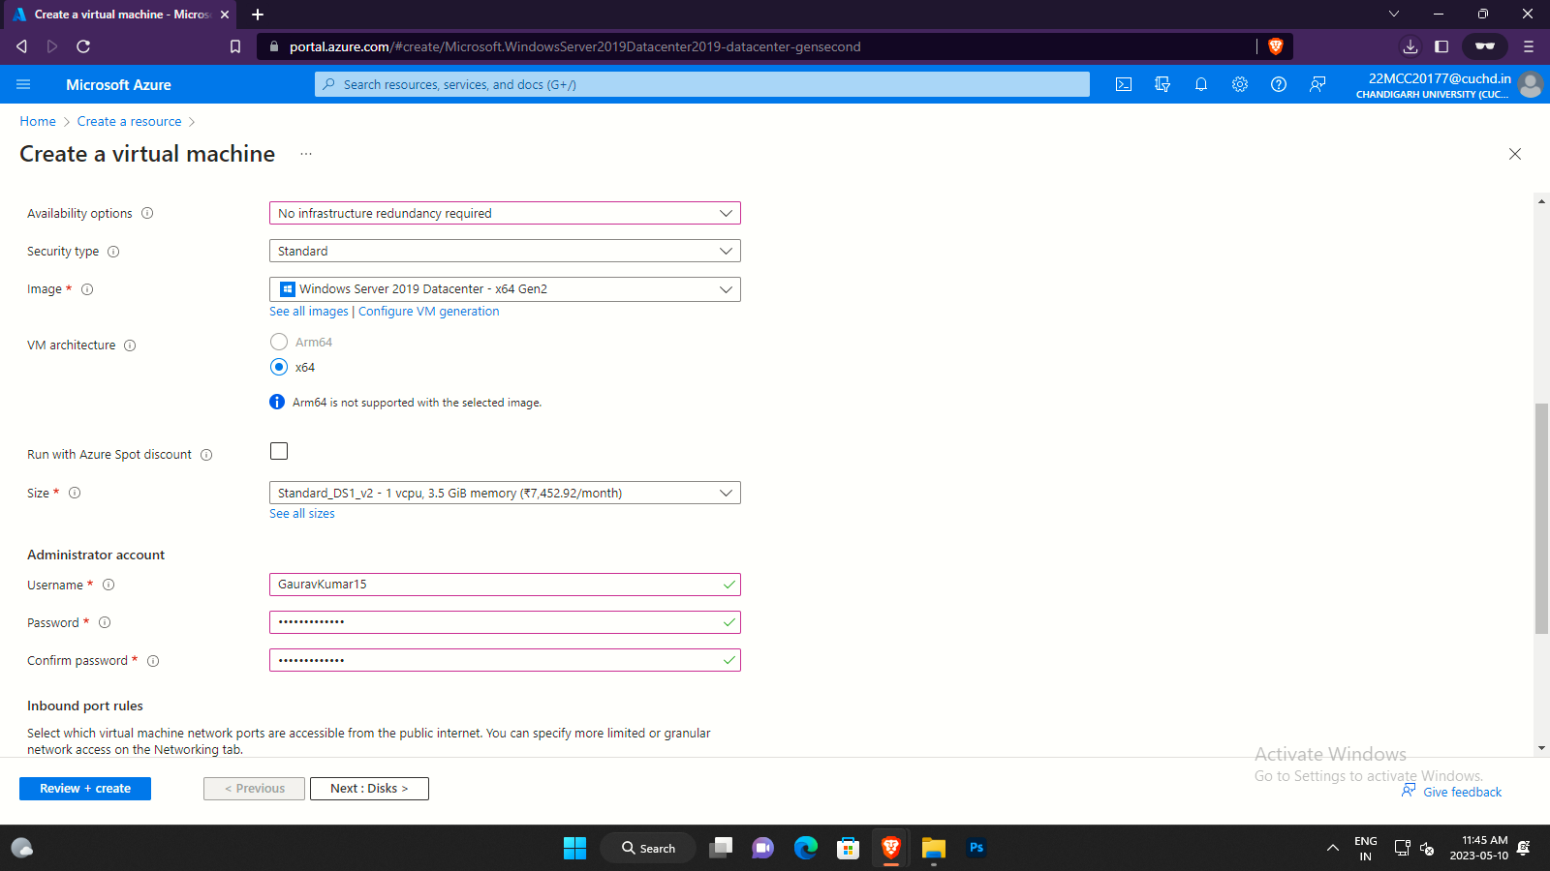

**Step 5)** After that go to **disk tab** and select **Standard HDD** under **OS disk type.**

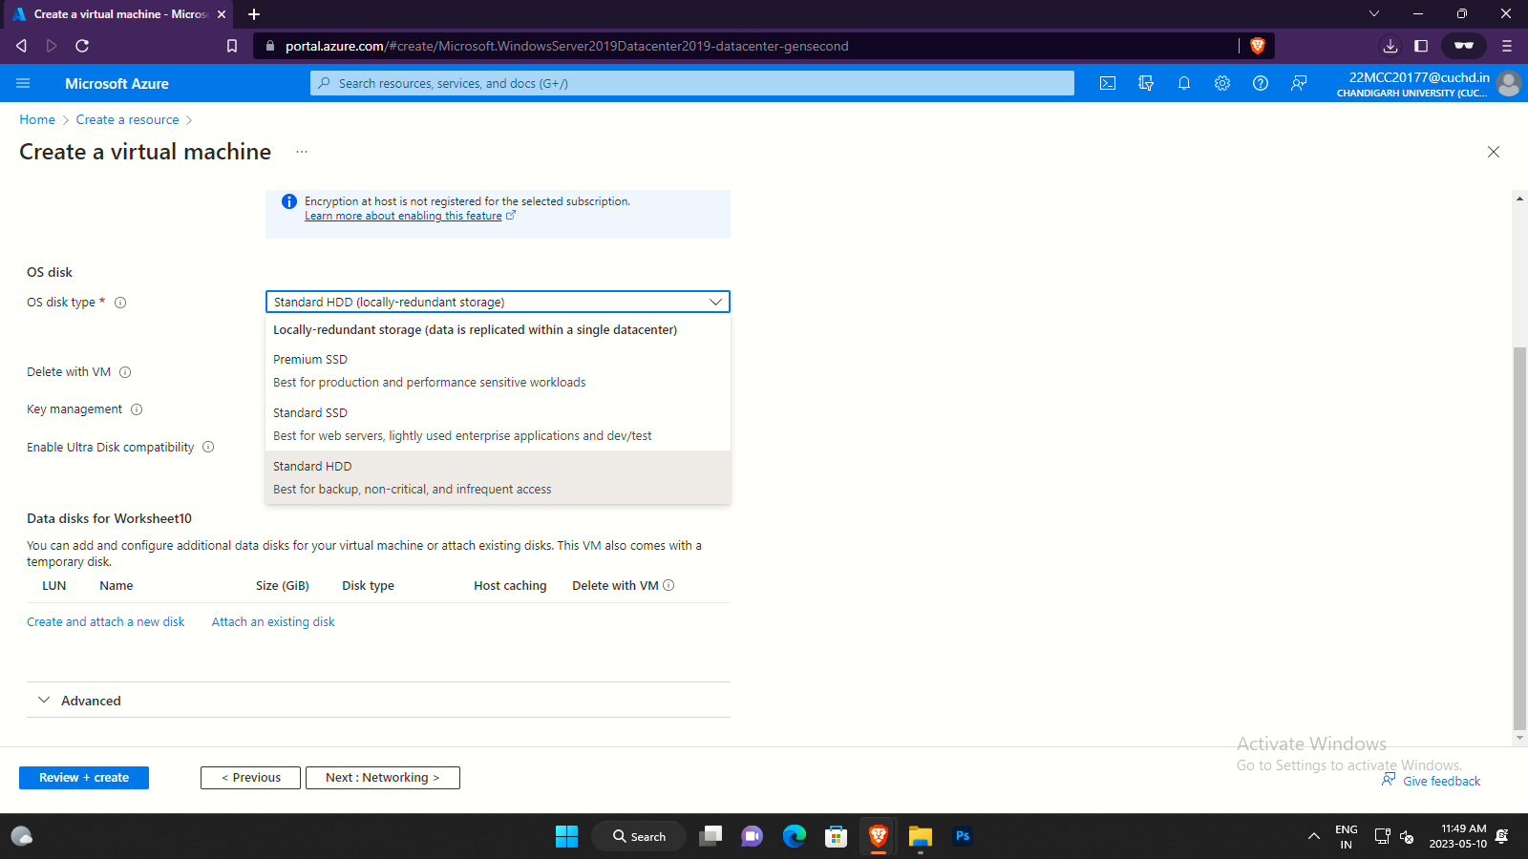

**Step 6)** Then go to **Tags tab** and create a new **key:value** and enter **“name”** inname and leave value blank.

**Step 7)** After all that click on **Review+Create.** Aftersome time,your Deployment/Resource will be ready.

**Step 8)** Once Resource are ready click on **Go to resource.**

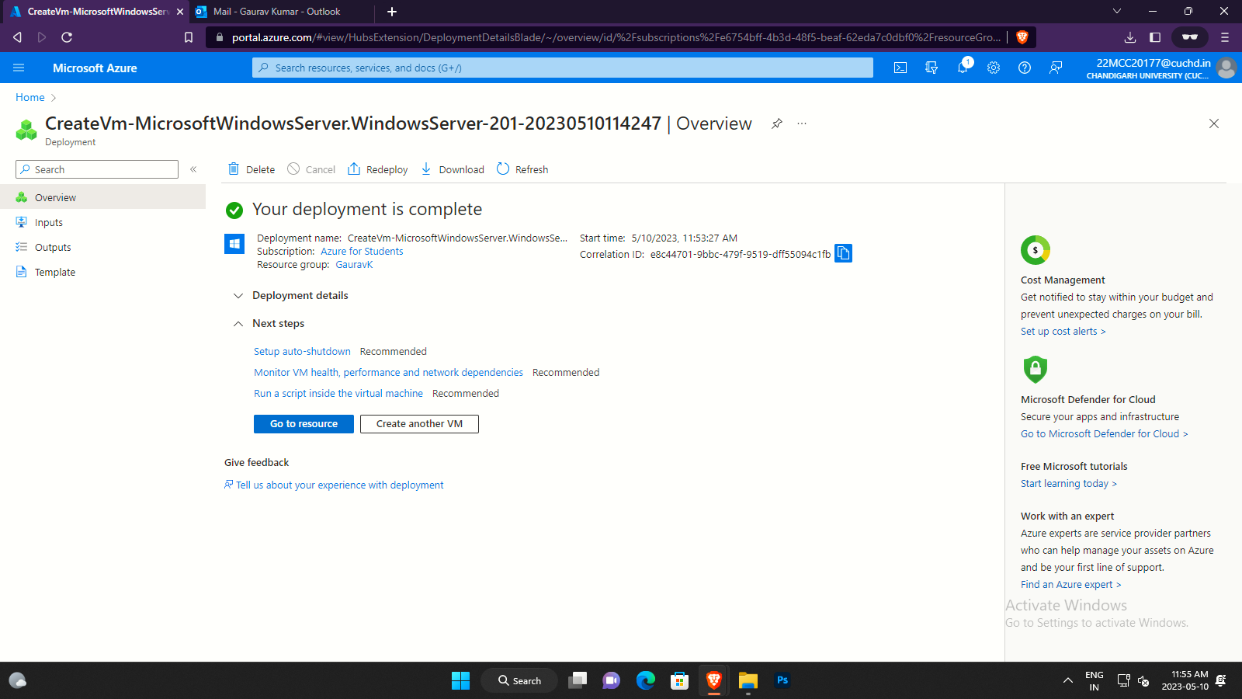

**Step 9)** Open **Remote Desktop Connection** tool, and type in the public IP address provided by azure for your VM in home tab of tour resources. After that click on **connect.**

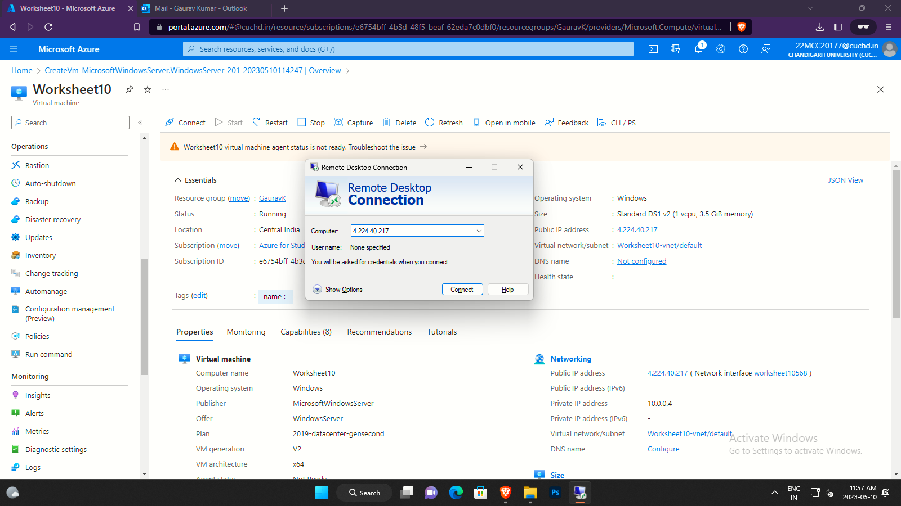

**Step 10)** A new pop-up window will appear asking for your credentials **enter your VM credentials** which you setup while creating VM on cloud.

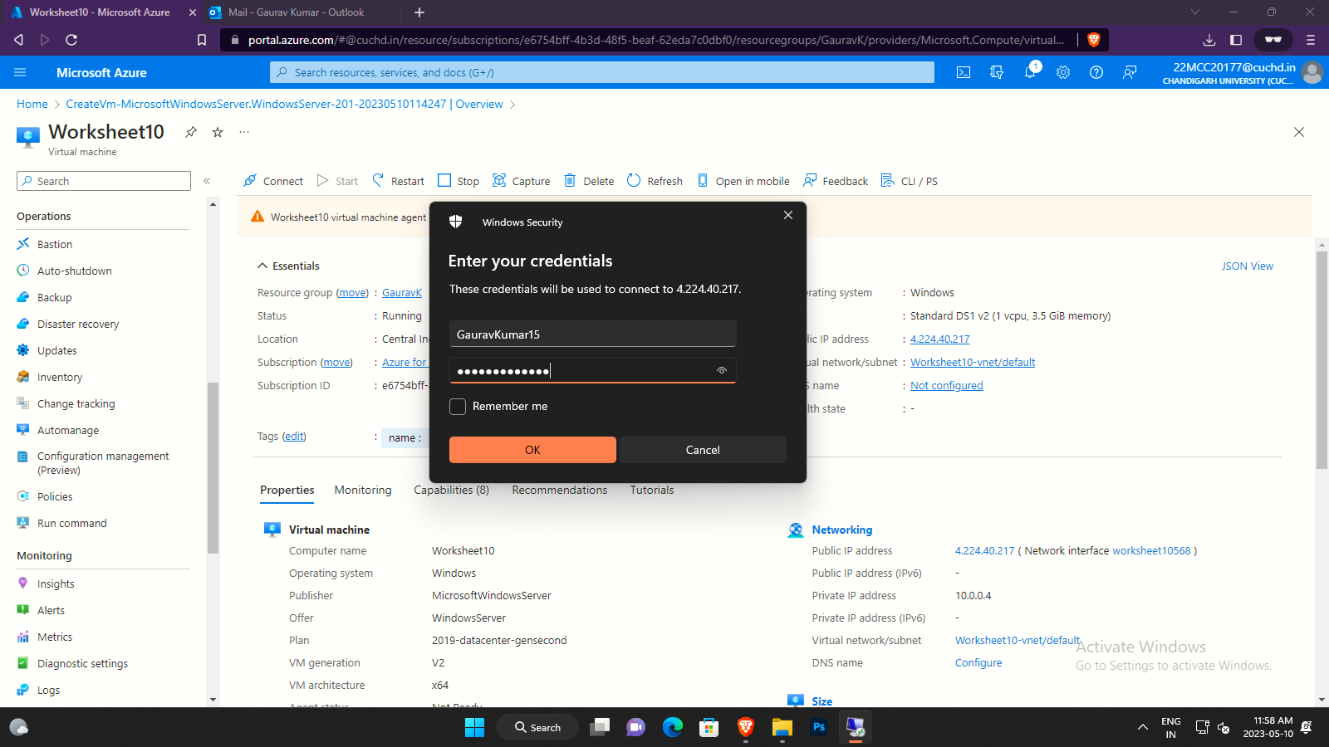

**Step 11)** Click on **yes** if a **Certificate error** window will appear.

**Step 12)** After that you will be in a new window environment.

**Step 13)** Nowyou canaccess your cloud VM and work on it.

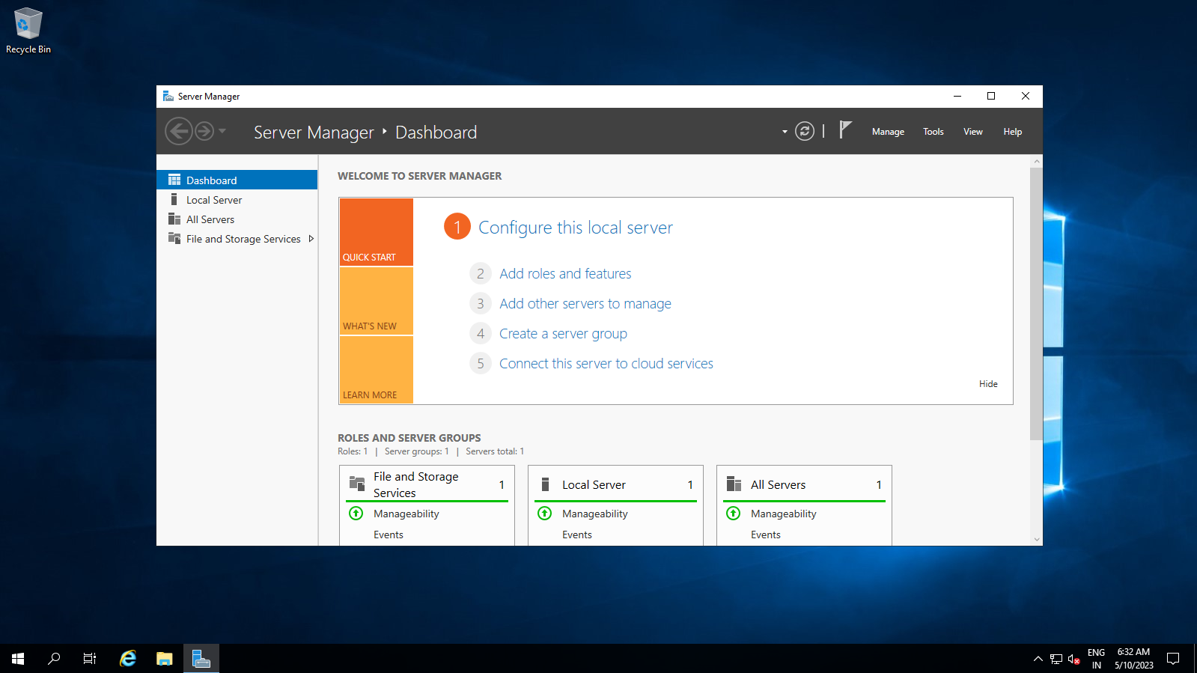

**Learning Outcomes (What I have learned)**

* I Learned to: -
  + - * Create a VM on azure Cloud.
      * Access cloud VM using remote connection tool.

**Evaluation Grid:**

|  |  |  |  |
| --- | --- | --- | --- |
| Sr. No. | Parameters | Marks Obtained | Maximum Marks |
| 1. | Demonstration and Performance (Quiz) |  | 22 |
| 2. | Worksheet |  | 8 |